Construct an ER diagram for a company in DBMS

Problem
Draw of ER model for company considering the following constraints −
- In a company, an employee works on many projects which are controlled by one department.
- One employee supervises many employees.
- An employee has one or more dependents.
- One employee manages one department.

Solution
Follow the steps given below to draw an ER model for the company −

Step 1 − Identify the entity sets
The entity set has multiple instances in a given business scenario.
As per the given constraints the entity sets are as follows:
- Employee
- Department
- Project
- Dependent

Step 2 − Identify the attributes for the given entities
- Employee − The relevant attributes are name, ssn, sex, address, salary.
- Department − The relevant attributes are Name, number of employees, location.
- Project − The relevant attributes are number, name, location.
- Dependent − The relevant attributes are name, sex, birth date, relationship.

Step 3 − Identify the Key attributes
- SSN is the key attribute for Employee.
- Number is the key attribute for the Department.
- Number is the key attribute for Project.
- Name is the key attribute for a dependent entity.

Step 4 − Identify the relationship between entity sets
- Multiple employees work for a single department and one department has multiple employees. Hence, the relationship between employee and department is many to one.
- 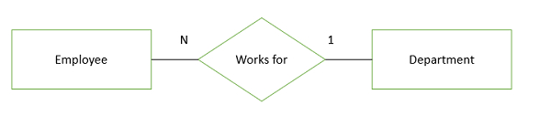Single employee manages the entire department and one department is handled by one manager.
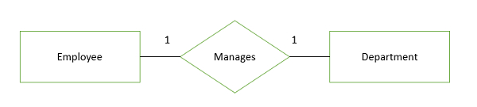
- Each department is controlled by the number of projects and the number of projects handled by a single department. Hence, the relationship between department and project is one-to-many.
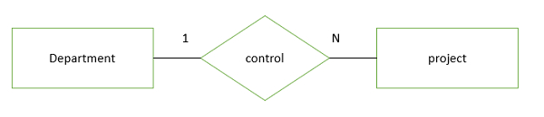
- One employee dependent is of multiple dependent and multiple dependents are of single employee. Hence, the relationship between employee and dependent is one- to-many.
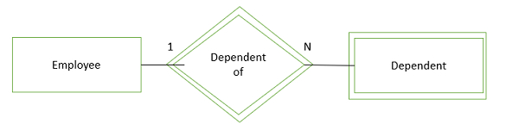
Dependent is a weak entity which is denoted by a double rectangle, the entity which does not contain a primary key is known as weak entity.

Step 5 − Complete ER diagram
The complete ER diagram is as follows −
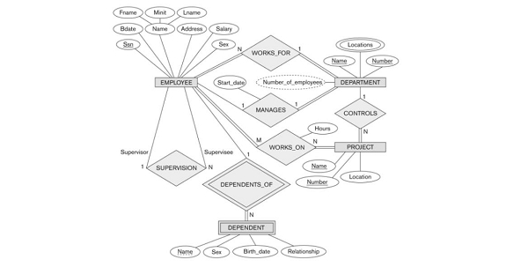

Construct an ER diagram for the Library management system(DBMS)

Problem
Draw an ER model for library management application considering the following constraints −
- In a library multiple students can enroll.
- Students can become a member by paying an appropriate fee.
- The books in the library are identified by a unique ID.
- Students can borrow multiple books from subscribed libraries.

Solution
Follow the steps given below to draw an ER model for the library management application −

Step 1 − Identify the entity sets
The entity set has multiple instances in a given business scenario.
As per the given constraints the entity sets are as follows −
- Book
- Publisher
- Member
- Section
- Granter

Step 2 − Identify the attributes for the given entities
- Book − The relevant attributes are title, author, price, Isbn.
- Member − The relevant attributes are Name, Bday, MID, address, phone, age.
- Section − The relevant attributes are Sid, name, phone.
- Publisher − The relevant attributes are name, phone, Pid, address.
- Granter − The relevant attributes are phone, name, Nic, post, address.

Step 3 − Identify the Key attributes
- Sid is the key attribute for the section.
- Mid is the key attribute for member entities.
- Isbn is the key attribute for a book entity.
- Pid is the key attribute for a publisher entity.
- Nic is the key attribute for a granter entity.

Step 4 − Identify the relationship between entity sets
- Multiple books are arranged in a single section and one section has multiple books. Hence, the relationship between book and section is many to one.
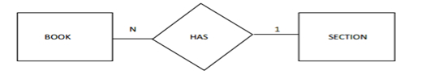
- One member borrows multiple books and multiple books can borrow a single person. Hence, the relationship between member and book is one-to-many.
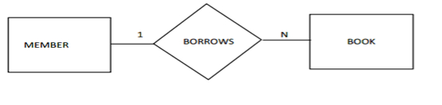
- One publisher can supply multiple books and multiple books can be supplied by a single publisher. Hence, the relationship between publisher and book is one-to-many.
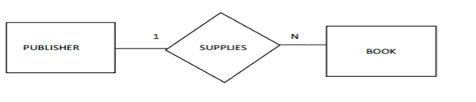
- One granter can grant multiple members and multiple members can grant a single granter. Hence, the relationship between grantor and member is one-to-many.
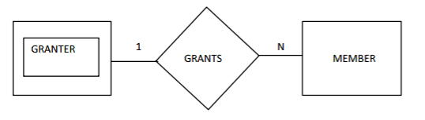

Step 5 − Complete ER diagram
The complete ER diagram is as follows −
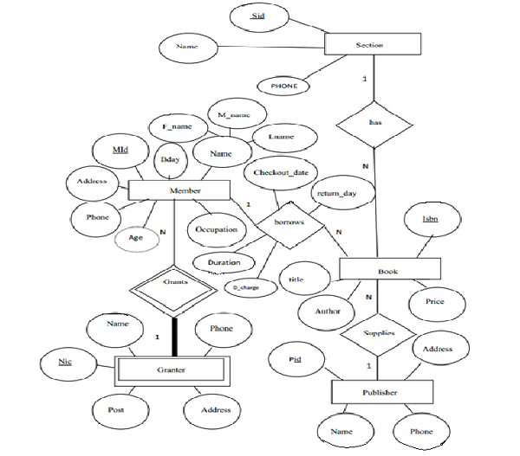

Construct an ER diagram for the Banking system in DBMS

Problem
Draw an ER model of the Banking database application considering the following constraints −
- A bank has many entities.
- Each customer has multiple accounts.
- Multiple customers belong to a single branch.
- Single customer can borrow multiple loans.
- A branch has multiple employees.

Solution
Follow the steps given below to draw an ER model of the Banking database application −

Step 1 − Identify the entity sets
The entity set has multiple instances in a given business scenario.
As per the given constraints the entity sets are as follows −
- Customer
- Account
- Account
- Loan
- Loan

Step 2 − Identify the attributes for the given entities
- Customer − the relevant attributes are customerName, CustomerID, address.
- Account − The relevant attributes are AccountNo, balance.
- Branch − The relevant attributes are branchID, branchName, address.
- Loan − The relevant attributes are loanNo, paymentMode, dateOfLoan, and amount.
- Employee − The relevant attributes are empID, empName, dateOfJoin, experience, qualification.

Step 3 − Identify the Key attributes
- CustomerID is the key attribute for a customer.
- AccountNo is the key attribute for Account entities.
- BranchID is the key attribute for branch entities.
- LoanNo is the key attribute for a loan entity.
- EmpID is the key attribute for an Employee entity.

Step 4 − Identify the relationship between entity sets
- One customer is enrolled by multiple accounts and one account for multiple customers. Hence, the relationship is many to many.

- Many customers belong to one branch but one branch belongs to many customers. Hence, the relationship between customer and branch is many to one.
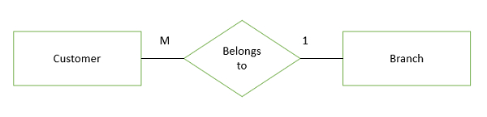
- One customer can borrow multiple loans in the same way multiple loans can borrow a single customer, hence the relationship between customer and loan is one to many.

- One branch has many employees and in the same way the number of employees works in a single branch.
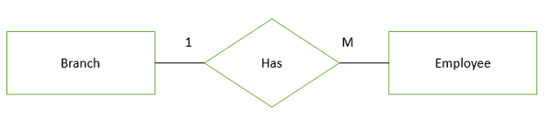

Step 5 − Complete ER diagram
The complete ER diagram is as follows –

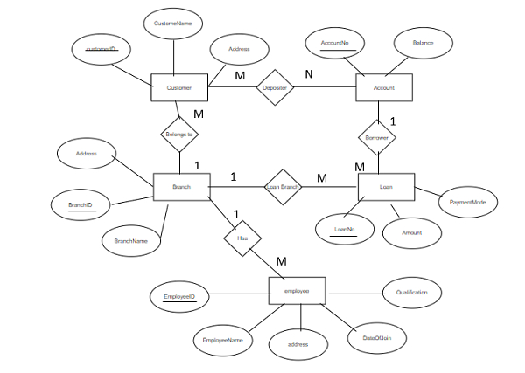

Draw an ER diagram for a University database application (DBMS)

Problem
Drawing of ER model of university database application considering the constraints −
- A university has many departments.
- Each department has multiple instructors (one person is HOD). Here the HOD refers to the head of department.
- An instructor belongs to only one department.
- Each department offers multiple courses, each subject is taught by a single instructor.
- A student may enroll for many courses offered by different departments.

Solution
Follow the steps given below to draw an Entity Relationship (ER) diagram for a University database application −

Step 1 − Identifying the entity sets.
The entity set has multiple instances in a given business scenario.
As per the given constraints the entity sets are as follows −
- Department
- Course
- Student
- Instructor
Head of the Department (HOD) is not an entity set. It is a relationship between the instructor and department entities.

Step 2 − Identifying the attributes for the given entities
- Department − the relevant attributes are department Name and location.
- Course − The relevant attributes are courseNo, course Name, Duration, and prerequisite.
- Instructor − The relevant attributes are Instructor Name, Room No, and telephone number.
- Student − The relevant attributes are Student No, Student Name, and date of birth.

Step 3 − Identifying the Key attributes
- Department Name is the key attribute for Department.
- CourseNo is the key attribute for Course entity.
- Instructor Name is the key attribute for the Instructor entity.
- StudentNo is the key attribute for Student entities.

Step 4 − Identifying the relationship between entity sets
- The department offers multiple courses and each course belongs to only one department, hence cardinality between department and course if one to many.

- One course is enrolled by multiple students and one student for multiple courses. Hence, relationships are many to many.

- One department has multiple instructors and one instructor belongs to one and only one department, hence the relationship is one to many.

- Each department has one “HOD” and one instructor is “HOD” for only one department, hence the relationship is one to one. Here, HOD refers to the head of the department.

- One course is taught by only one instructor but one instructor teaches many courses hence the relationship between course and instructor is many to one.

The relationship between instructor and student is not defined because of the following reasons −
- There is no significance in the relationship.
- We can always derive this relationship indirectly through course and instructors, and course and student.

Step 5 − Complete ER model
The complete ER Model is as follows −
